STUDENT MANAGEMENT SYSTEM
TOOL USAGE AND TASK ASSIGNMENT EVIDENCE

- Tool Used
Tool | Purpose
GitHub | Source code and team management
diagrams.net | DFD, Use Case, Class Diagram, Database Schema
VS Code | C++ implementation and debugging
Excel | Test cases

- Task Assignment
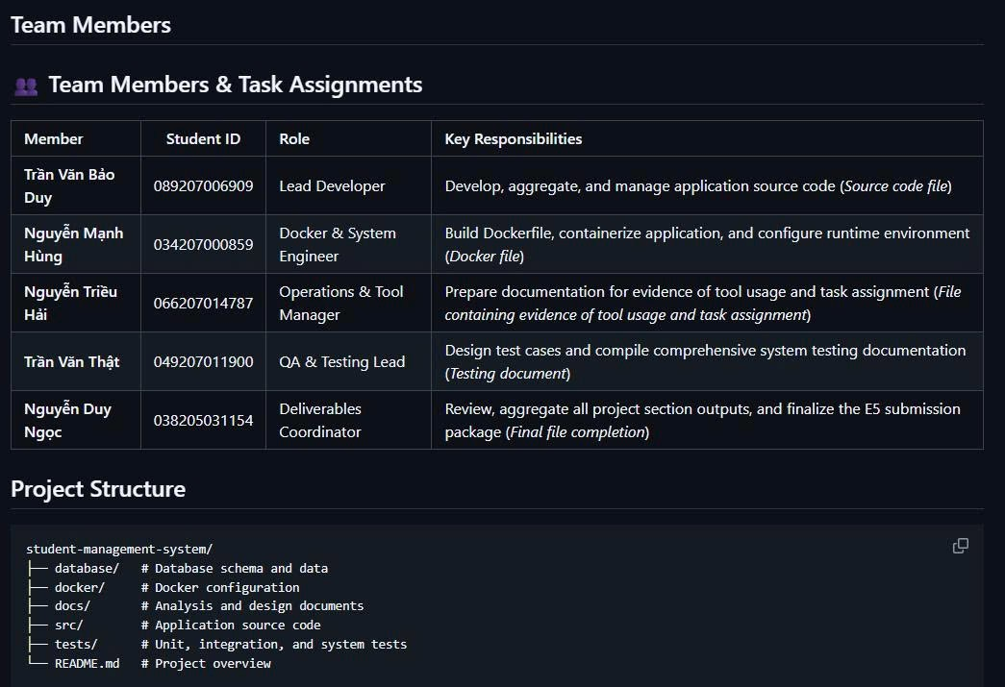
- Evidence of Tool Usage

3.1 GitHub:

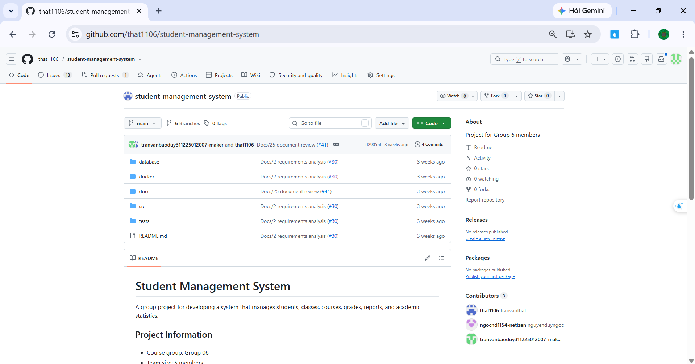
Repository: https://github.com/that1106/student-management-system
  - diagrams.net:
DFD - Context:
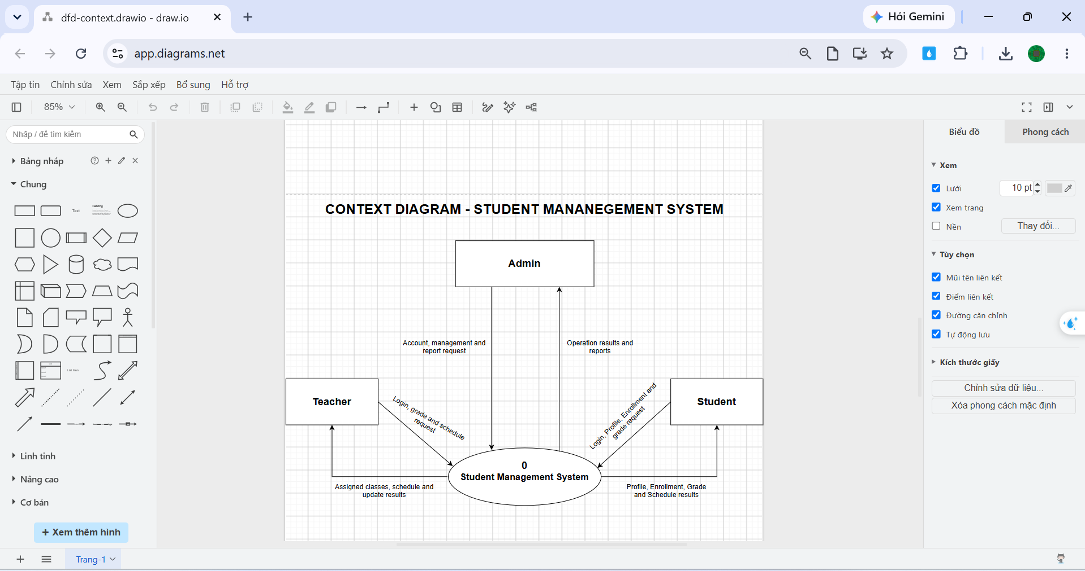
DFD Level 0:
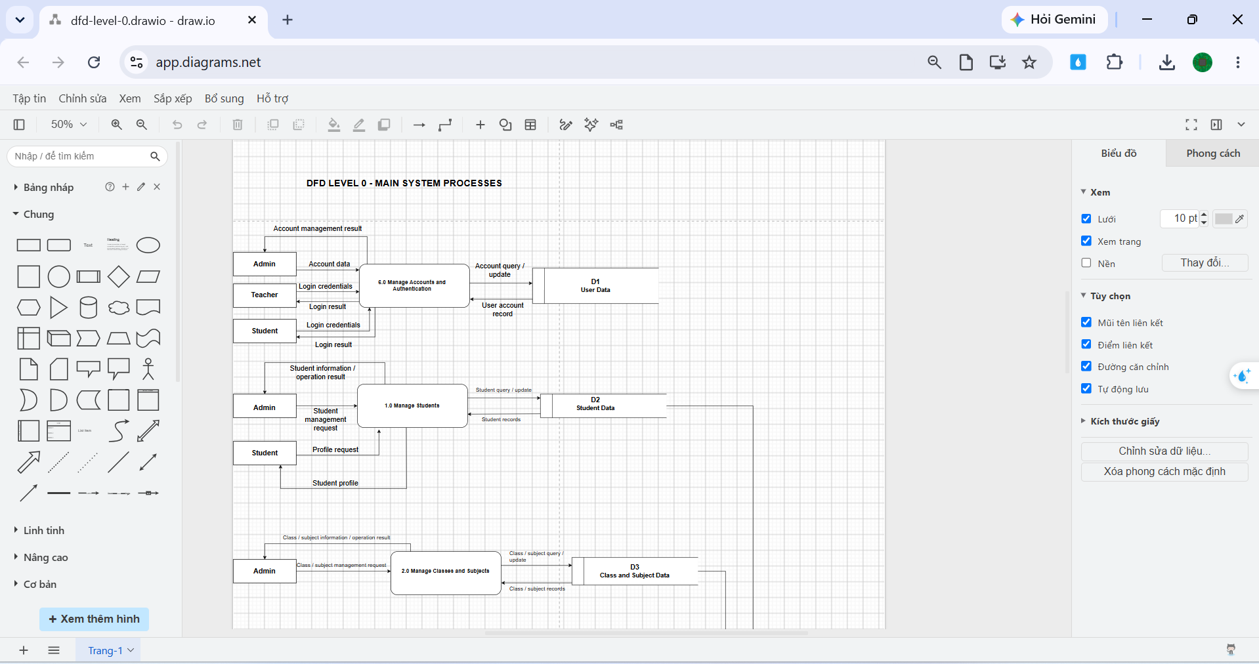
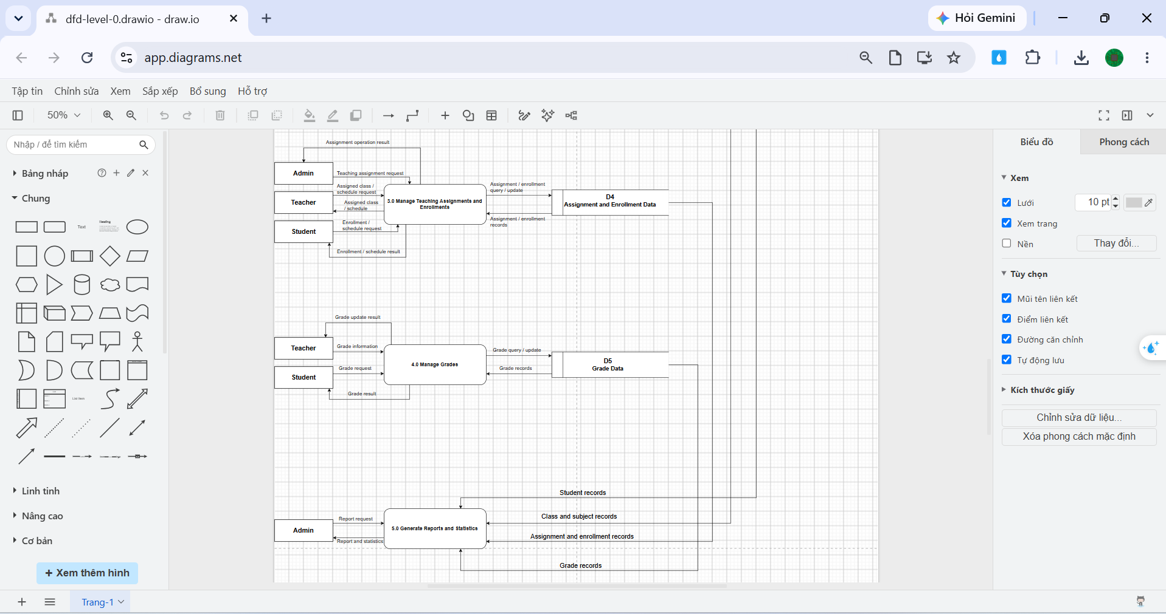
DFD Level 1:
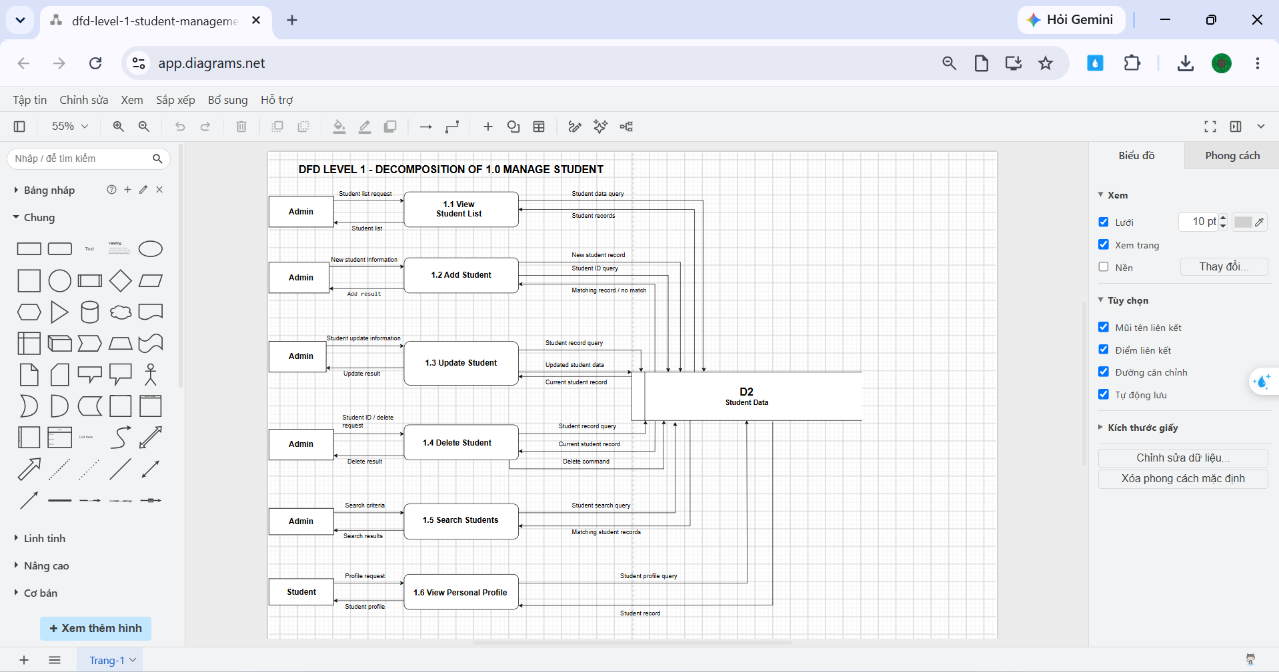
DFD Level 2:
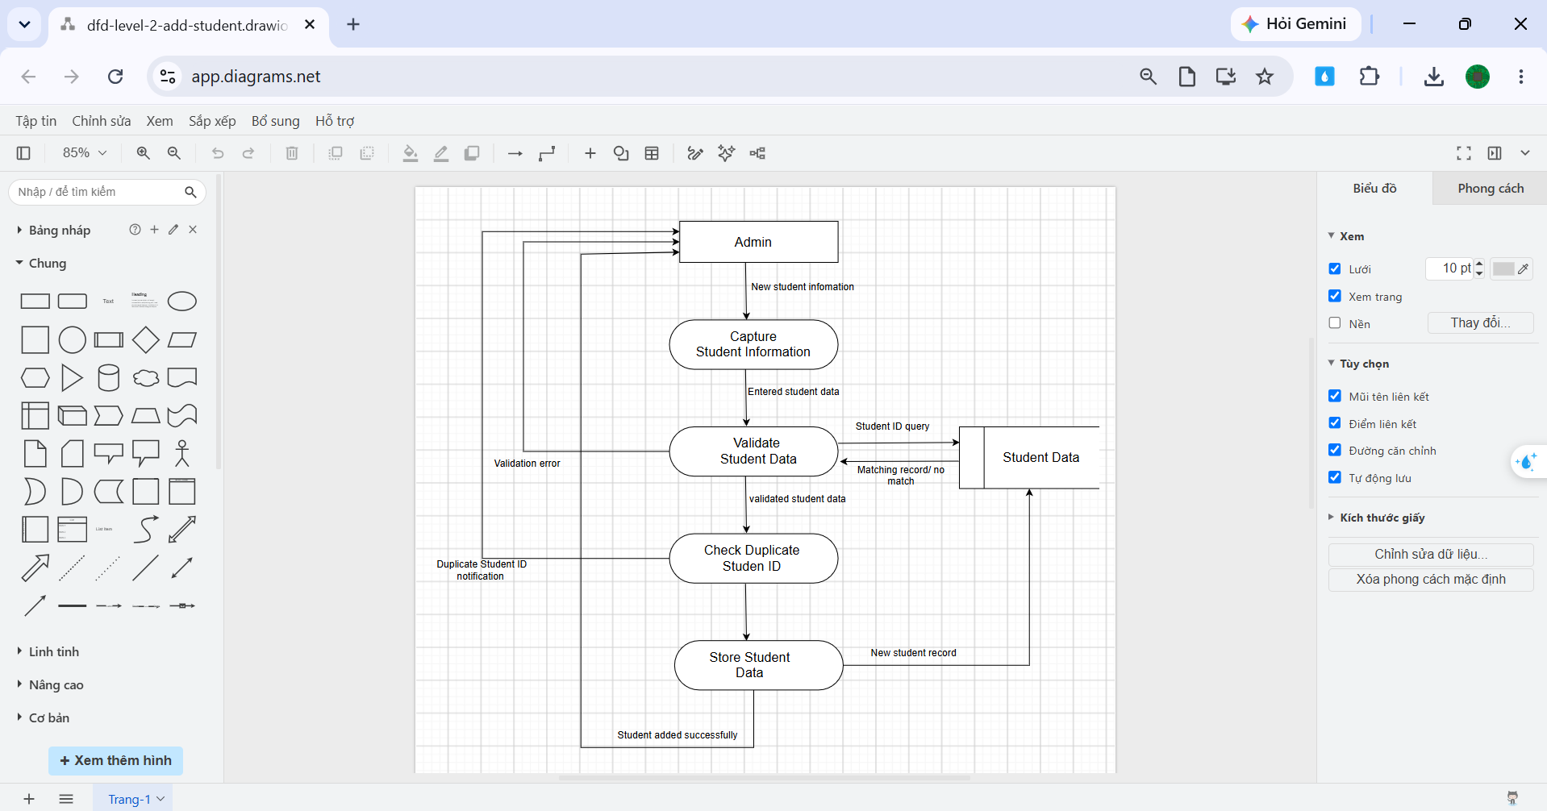
Use Case:
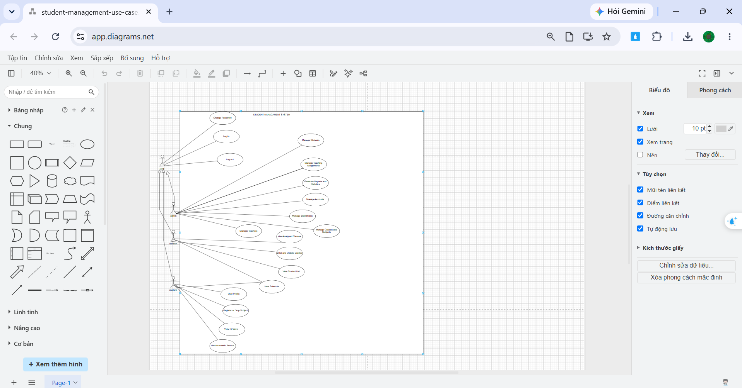
Class Diagram:
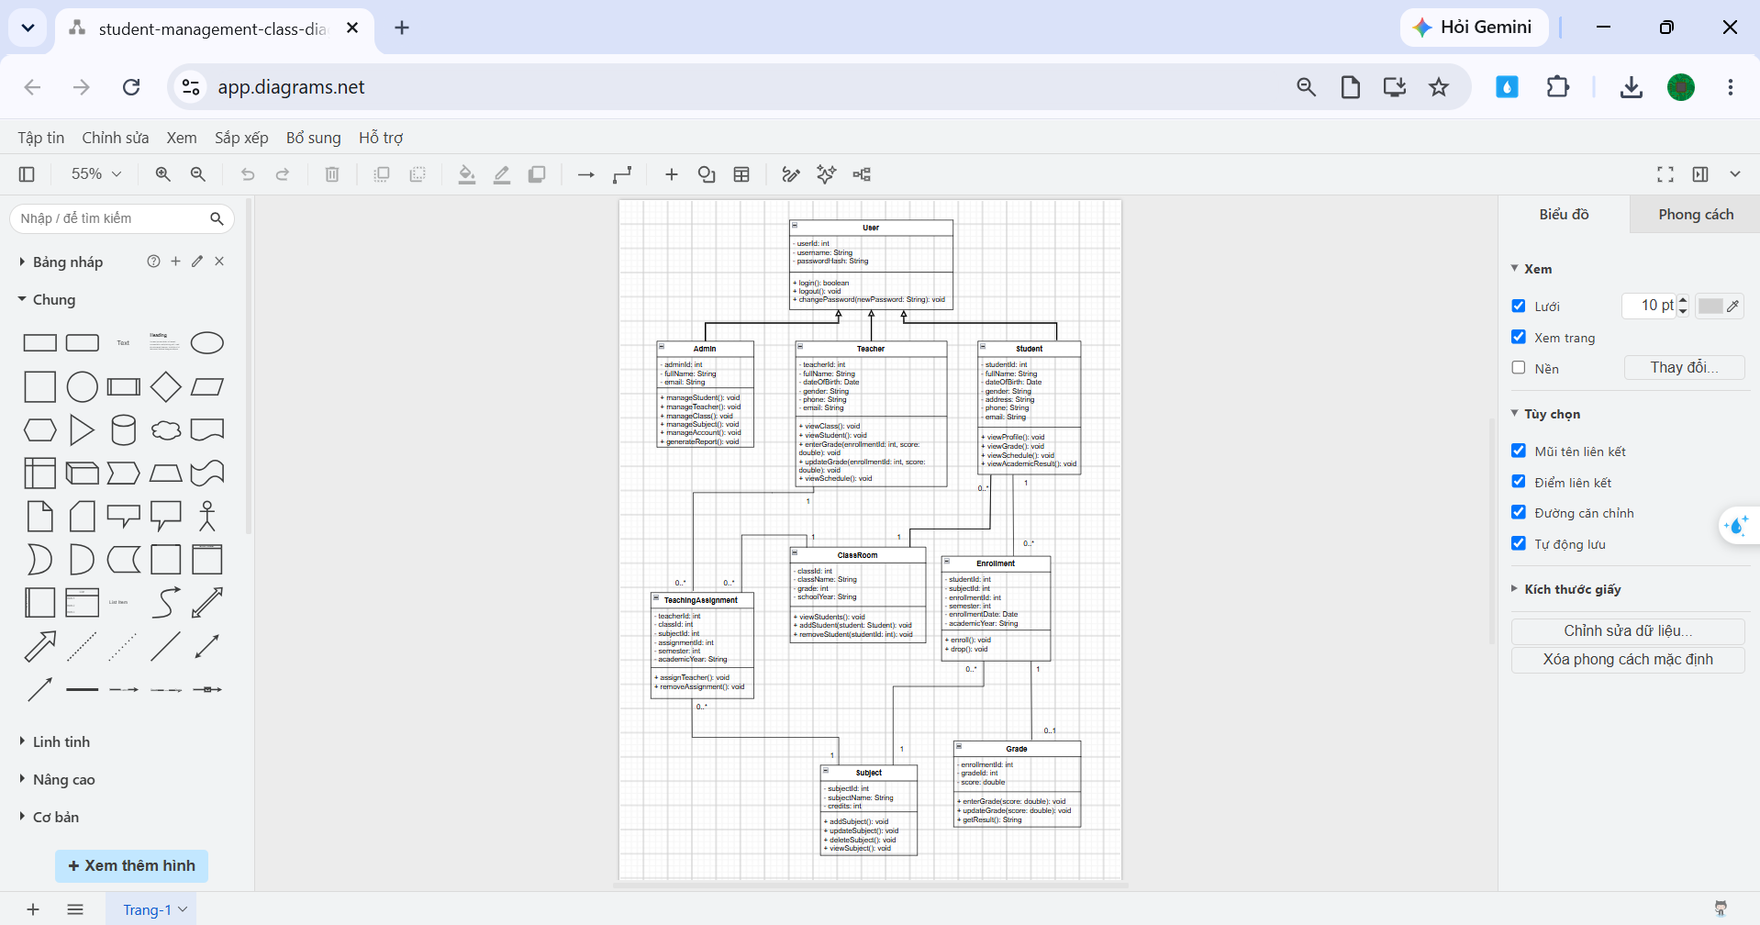
Database Schema:
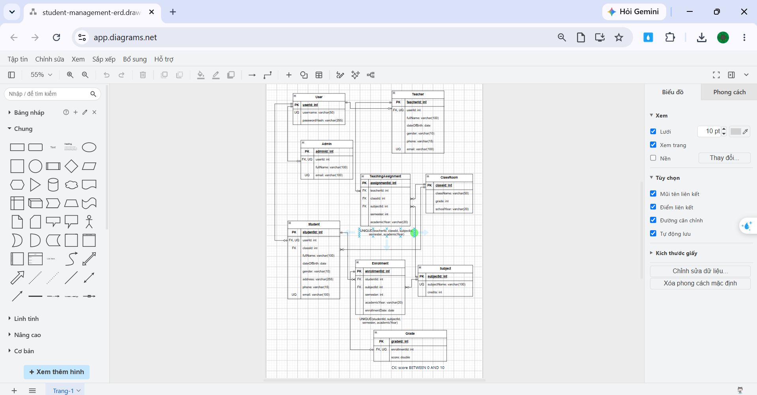
  - FIgma
UI/UX:
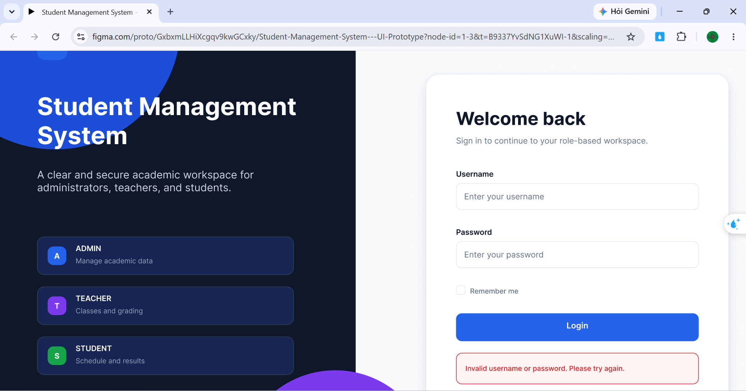
https://www.figma.com/proto/GxbxmLLHiXcgqv9kwGCxky/Student-Management-System---UI-Prototype?node-id=1-3&t=B9337YvSdNG1XuWI-1&scaling=min-zoom&content-scaling=fixed&page-id=0%3A1&starting-point-node-id=1%3A3
  - VS Code:
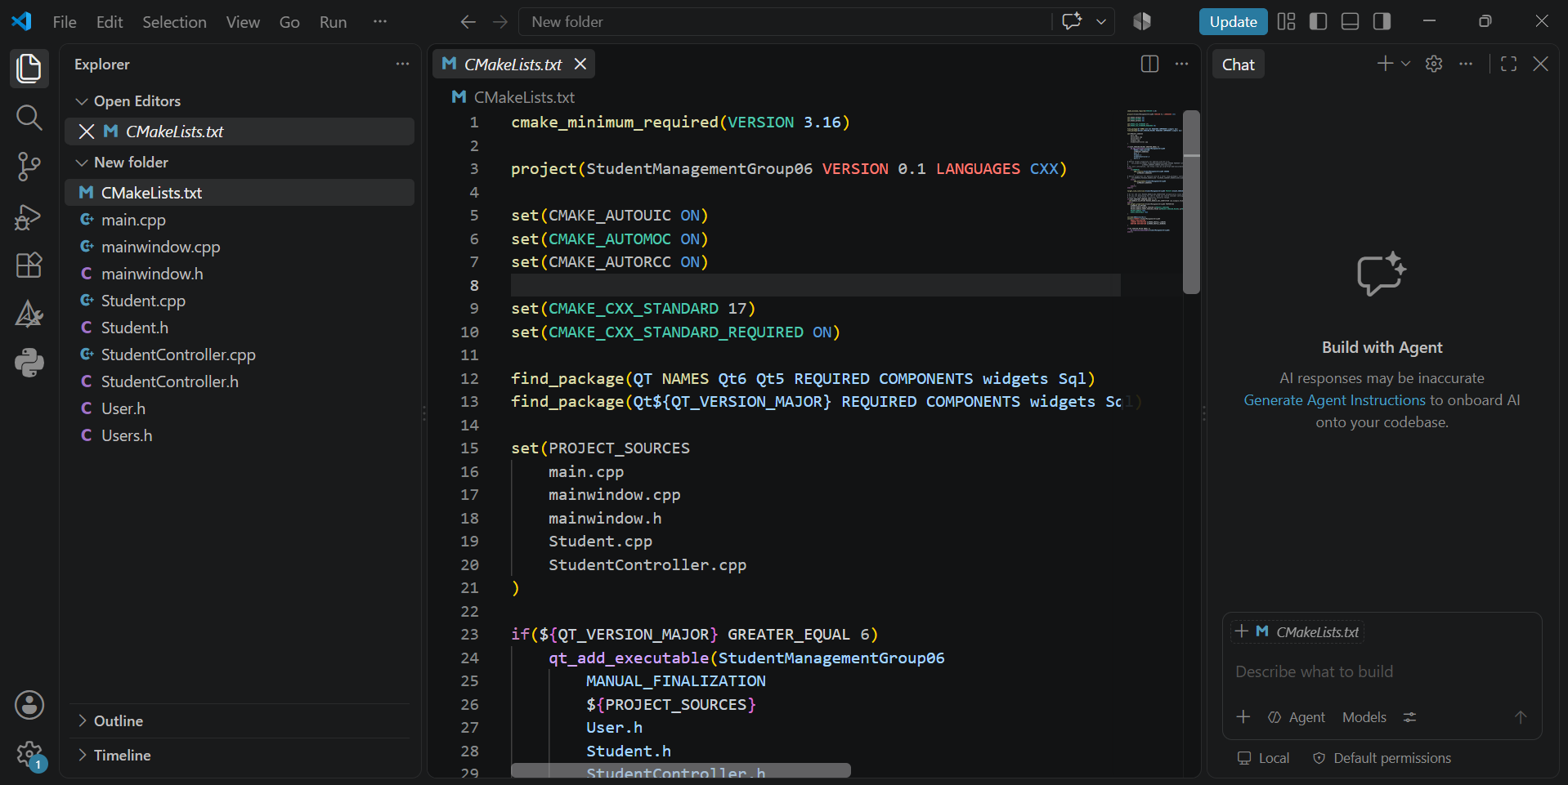
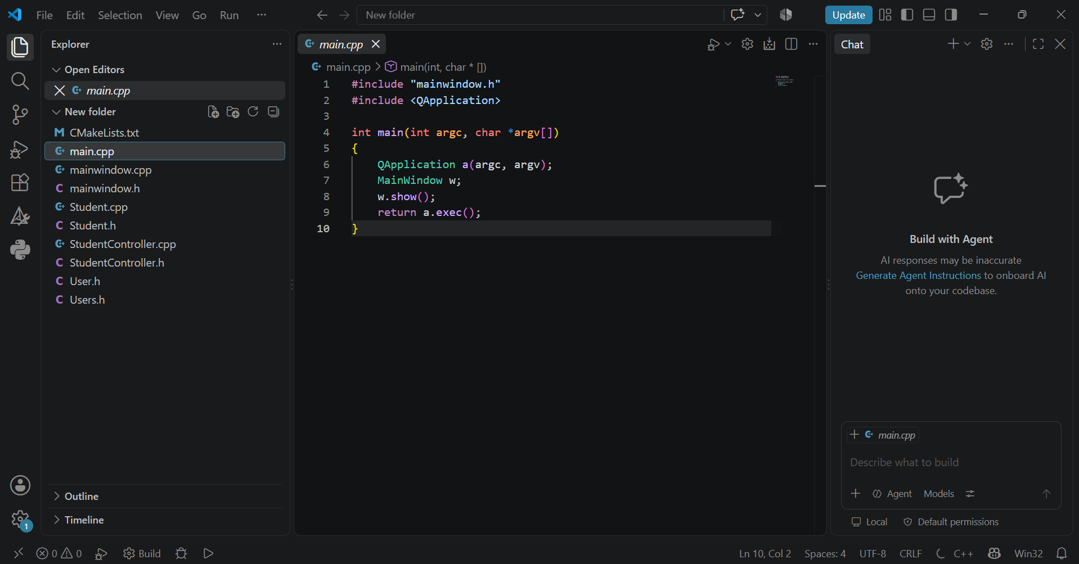
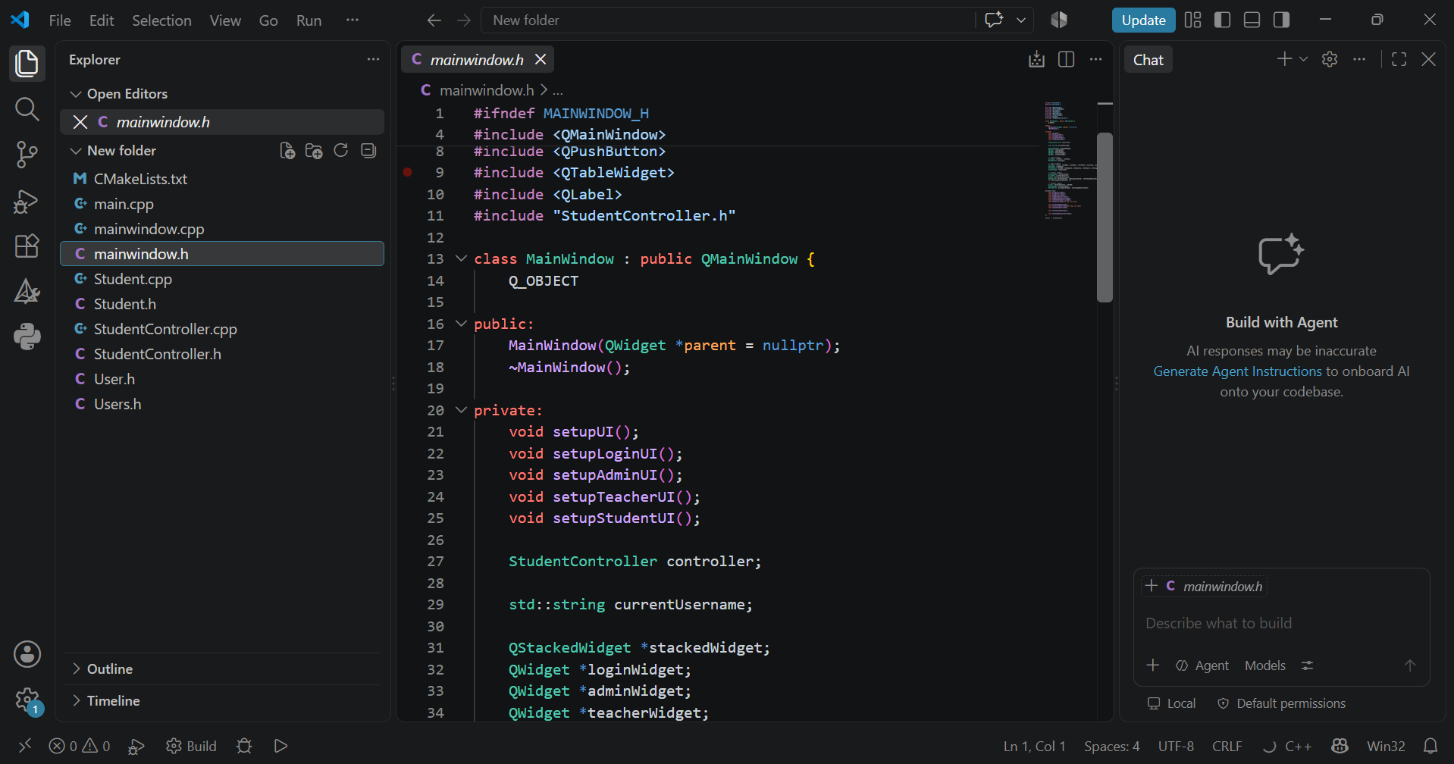
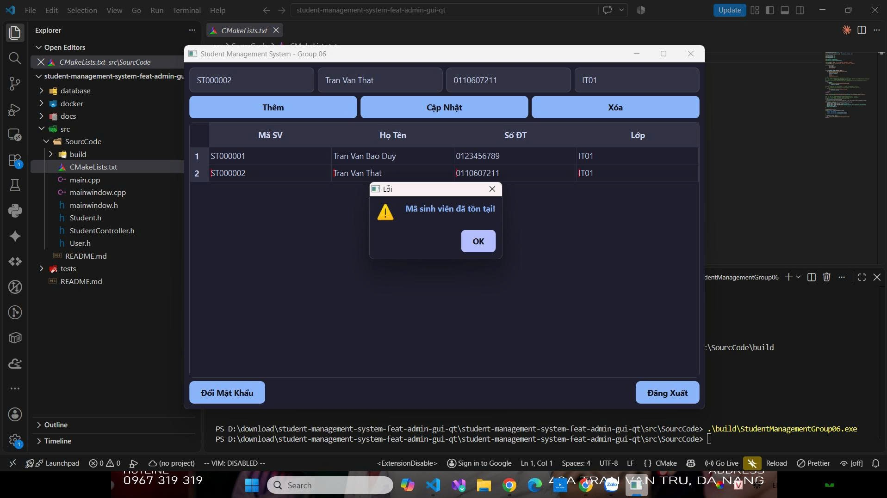
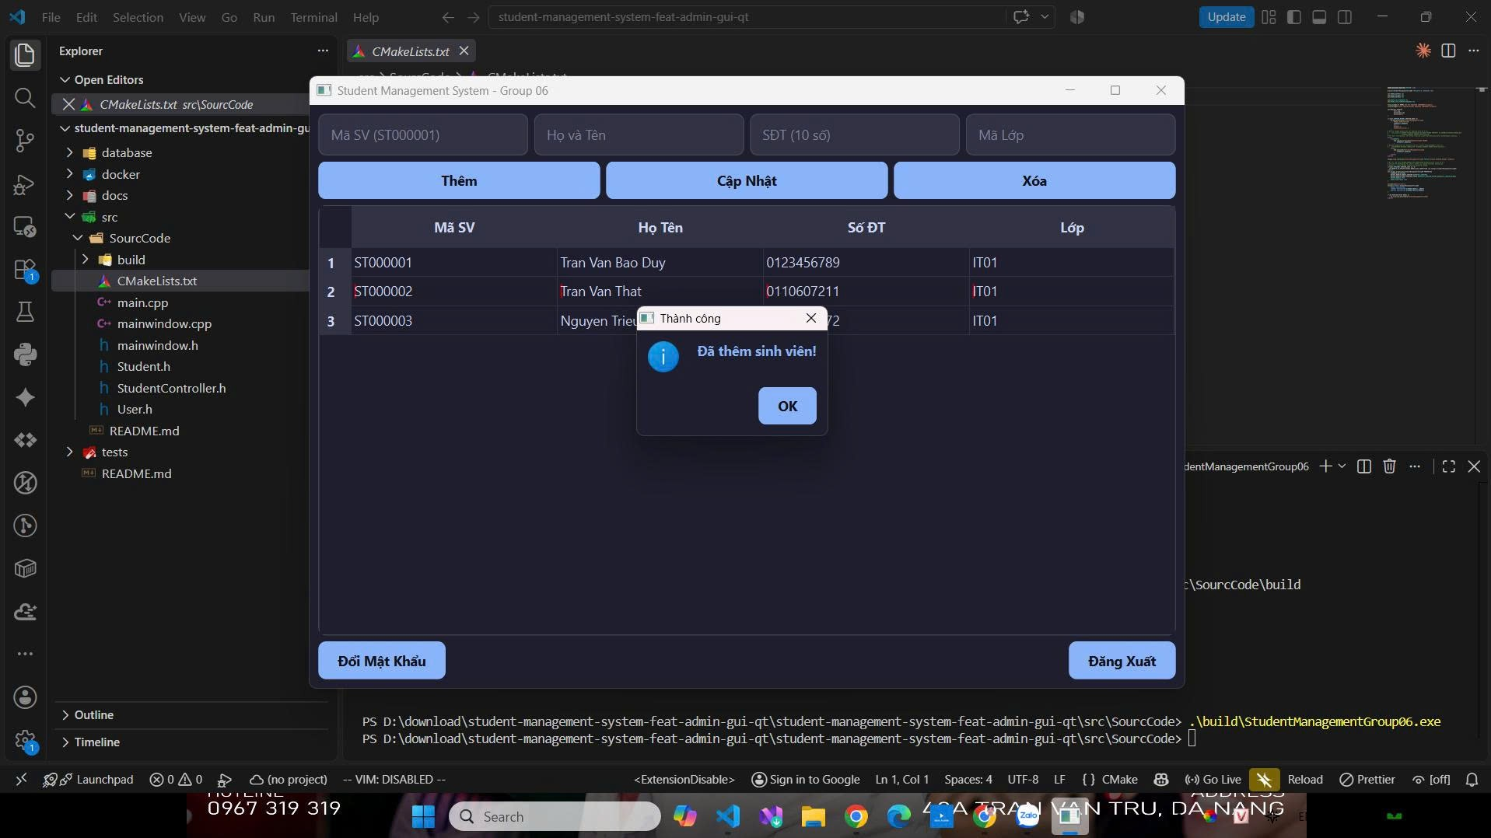

  - Excel:
